## horizontal line

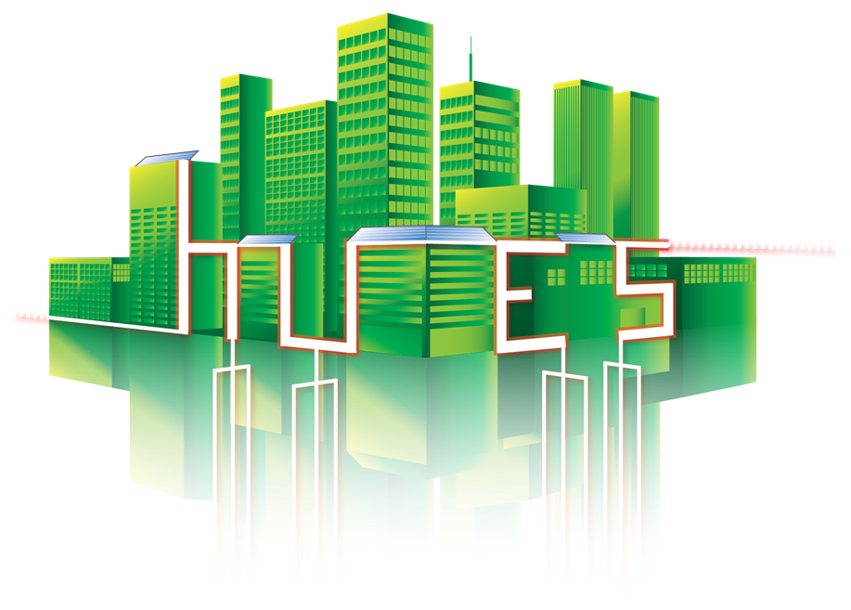

# Google Summer of Code 2017

# Urban Energy Systems Laboratory, Empa

Project Title : Visualization Dashboard for Empa-NEST

**Mentors**: Fricker Reto , Philipp Heer

# Project Plan

10.05.2017

Arushee Garg

Computer Science Graduate Student

Purdue University, Indiana 46323

Contact : 408-375-8923

Email : [arusheegarg@gmail.com](mailto:arusheegarg@gmail.com)

# 1. Project Aim

Project - 2. Visualization Dashboard for Empa-NEST

The aim of this project is to develop a visualization dashboard integrated into a Website based on node-red and javascript charting library Highcharts which will have a connection to the Microsoft SQL Database and OPC UA server. The trend data is logged into a SQL Database in the NEST-Cloud, which is accessible for researchers and technicians from all over the world. And the live data will be accessible via OPC UA server. To bring the big data to life it is essential to have attractive visualization charts.

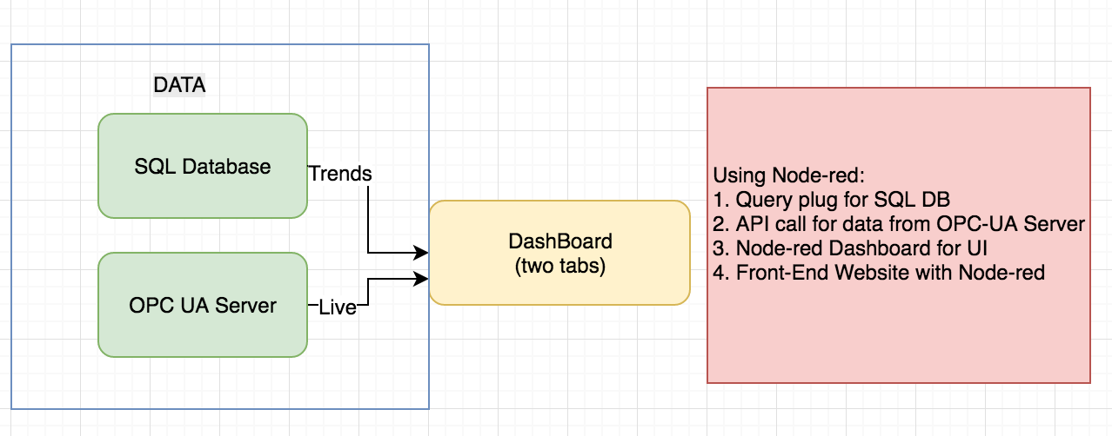

# 2. Timeline :

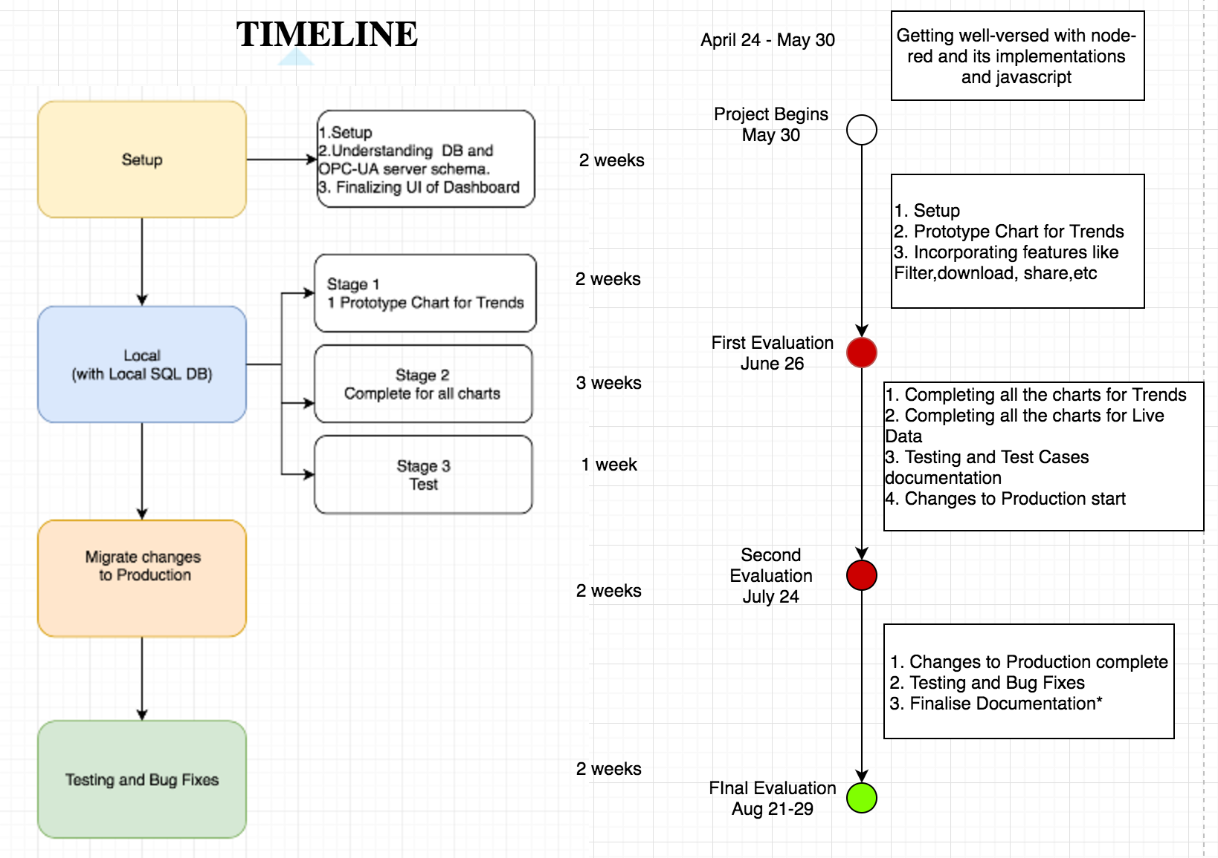

# 4. Tools and Technologies Used :

Will be using [Node-RED](https://nodered.org/) for the project, it is a programming tool for wiring together hardware devices, APIs and online services in new and interesting ways. Will be implementing Node-red with libraries- SQL node connection, OPC - UA server with FRED, Dashboard UI nodes , http nodes and javascript charting library Highcharts for creating the visualization dashboard and plugging in the data.

# Tools and Documentation

1. Swisscom Server : Virtual Desktop for work and all DB access
2. Github for all code maintenance : <https://github.com/arugarg/GSOC2017-VisualizationDashboard-EmpaNest>
3. The Dashboard can be accessed at the local or http://192.168.223.70:1880/ui/#/0

## Sample Node-red flows and dashboard created for the project

1. Individual Signals

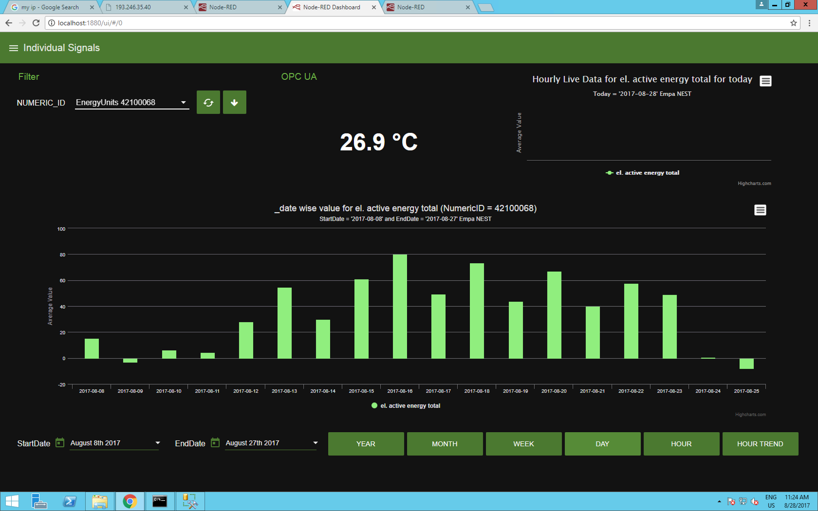

1. Weather Station

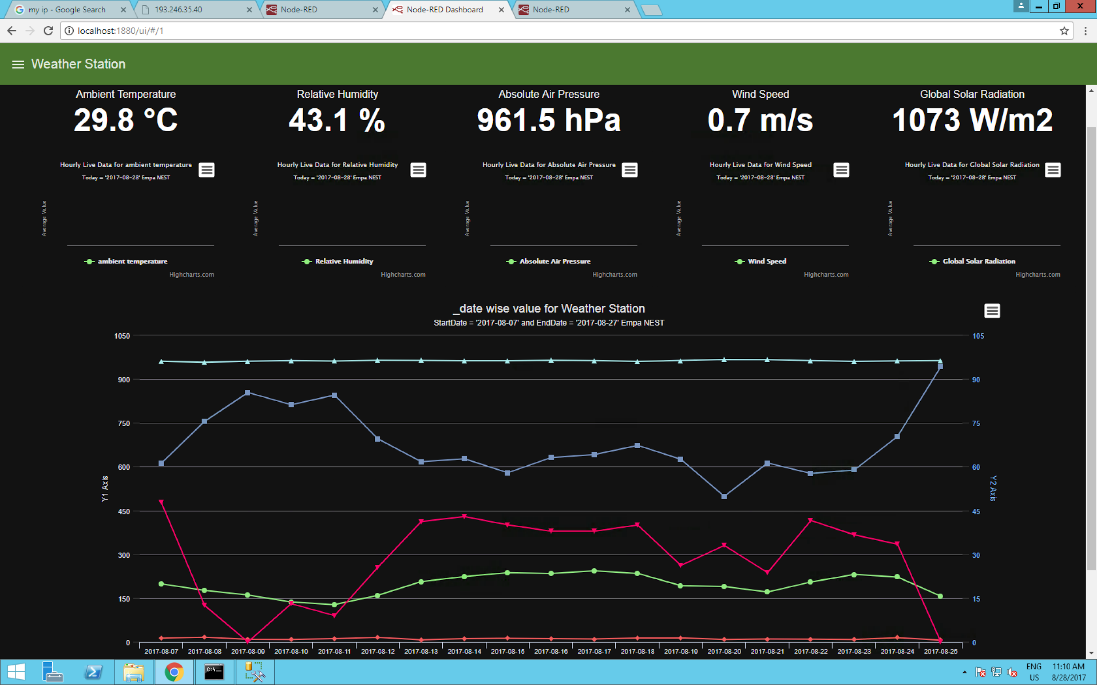

3. Live Dashboard:

